**Create a task in Task Scheduler:**

1. Open task Scheduler
2. Click on **Create Task**

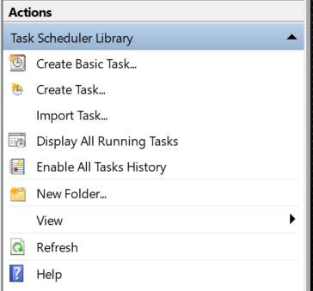

1. Enter the **Name** of your task & choose your OS in the **Configure for** option:

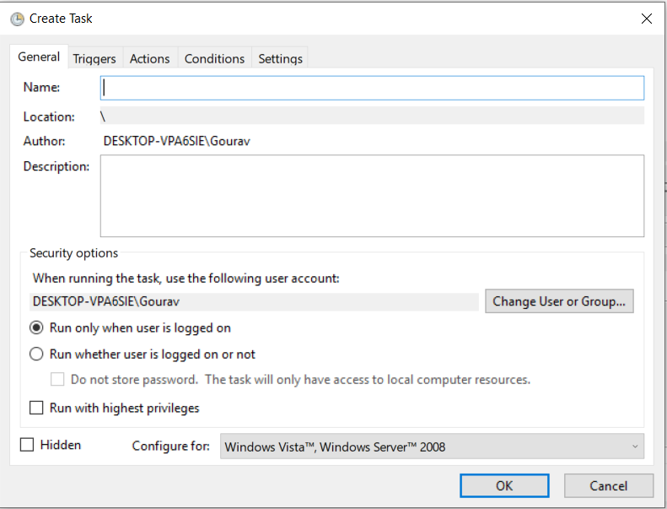

1. Click on **TRIGGERS** and the click on **New**  to create a new trigger

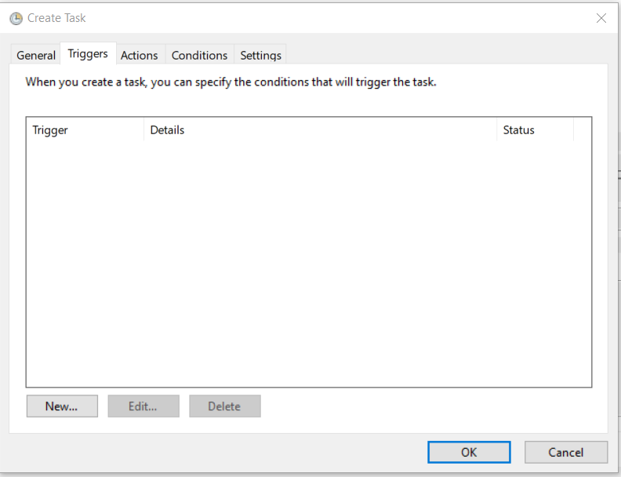

1. **Begin Task – at startup**

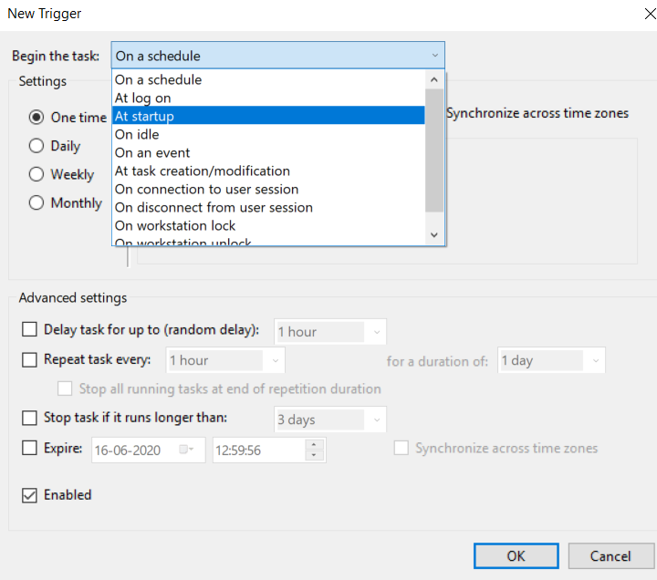

1. Set **Action – start a program**

**Program/script – address of script file**

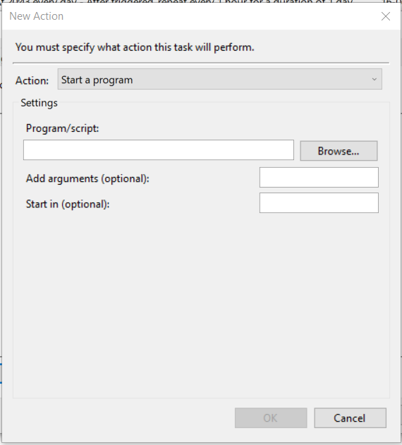

1. Set the Conditions

